This explains the time complexity and space complexity of an algorithm. It is represented in Best case, worst case and average case complexity.

Generally It can be 2 types 1) Linear (selection sort, linear search)
2) Logarithmic (Binary search, merge sort)

Linear: It will go as linear. EX: O(1), O(n)
Logarithmic: It is based on divide and conquer technique EX: O(log n), O(n log n)

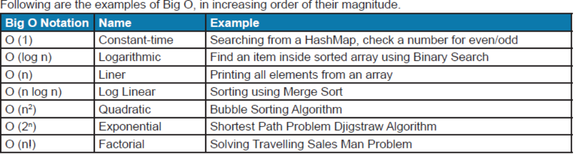

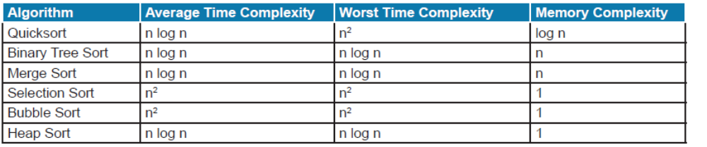

When is a sorting algorithm Stable ?
An algorithms is said to be stable if it maintains order of keys (i.e for comparing strings “test, past”… only t and p are taken, that is called key) that are equal. For example, suppose the following key-value pair need to be sorted based on key in ascending order
INPUT --> [(2,3) (1,2) (1,3) (3,1)]
Now there are two solution possible for the first two elements
OUTPUT1 --> [(1,2) (1,3) (2,3) (3,1)] --> stable sort because order is maintained
OUTPUT2 --> [(1,3) (1,2) (2,3) (3,1)] --> unstable sort because order changed from the original

INPUT →peach straw apple spork (compare only first letter and if 2 same letter are present.. the 2nd word should not go before 1st word.)
Stable-sorting by the first letter gives us:
OUTPUT1 : apple peach straw spork
In an unstable algorithm,
OUTPUT2 : straw or spork may be interchanged,

Examples of Stable Sort algorithms are: Binary Tree Sort, Bubble Sort, Merge Sort, Insertion Sort, etc
Unstable Sorting Algorithms: Heap Sort, Selection Sort, Quick Sort

Do you know what Sorting algorithm JDK uses for Java's Collections.sort(List<E>) method ?
Collections.sort(List<E>) uses Iterative merge sort algorithm, it requires fewer than n log(n) comparisons when the input array is partially sorted and this algorithm is guaranteed to be stable in nature.

